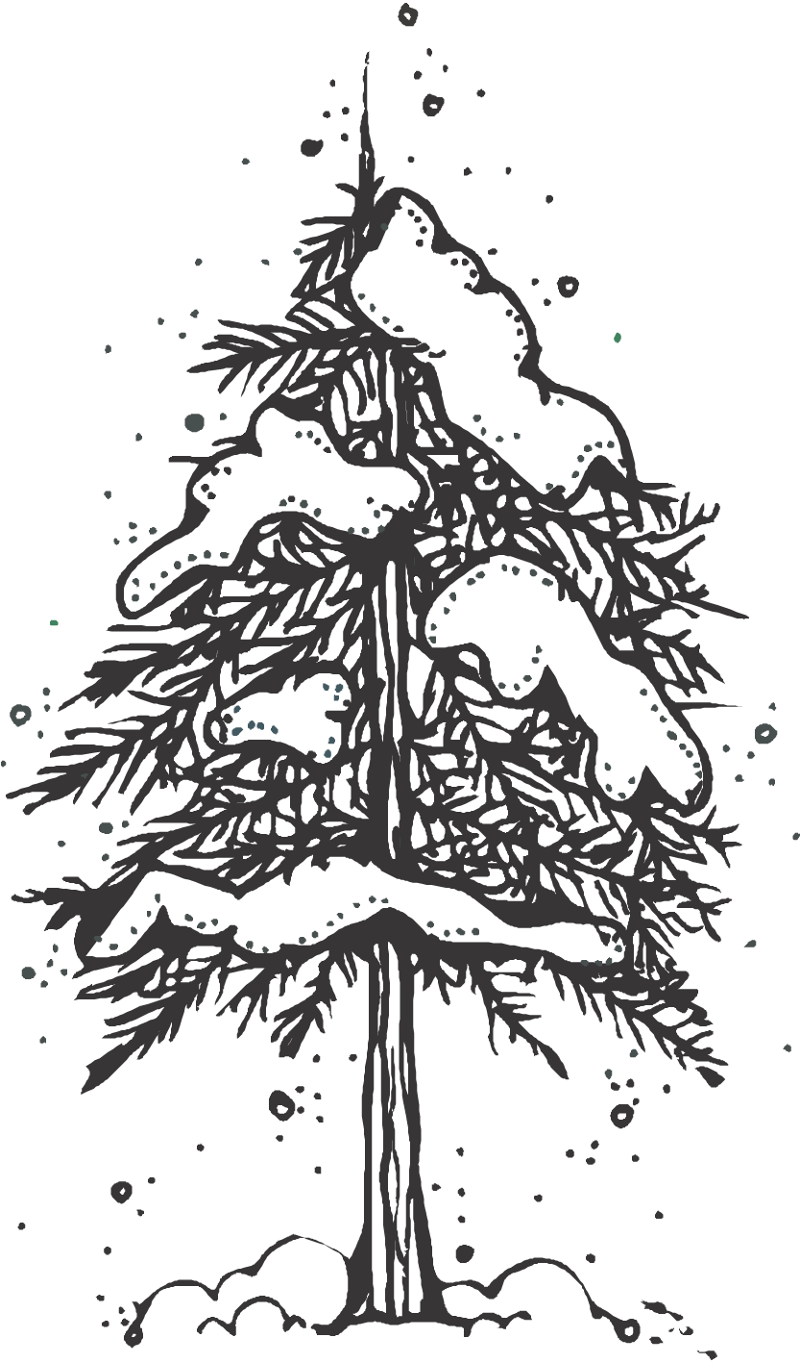
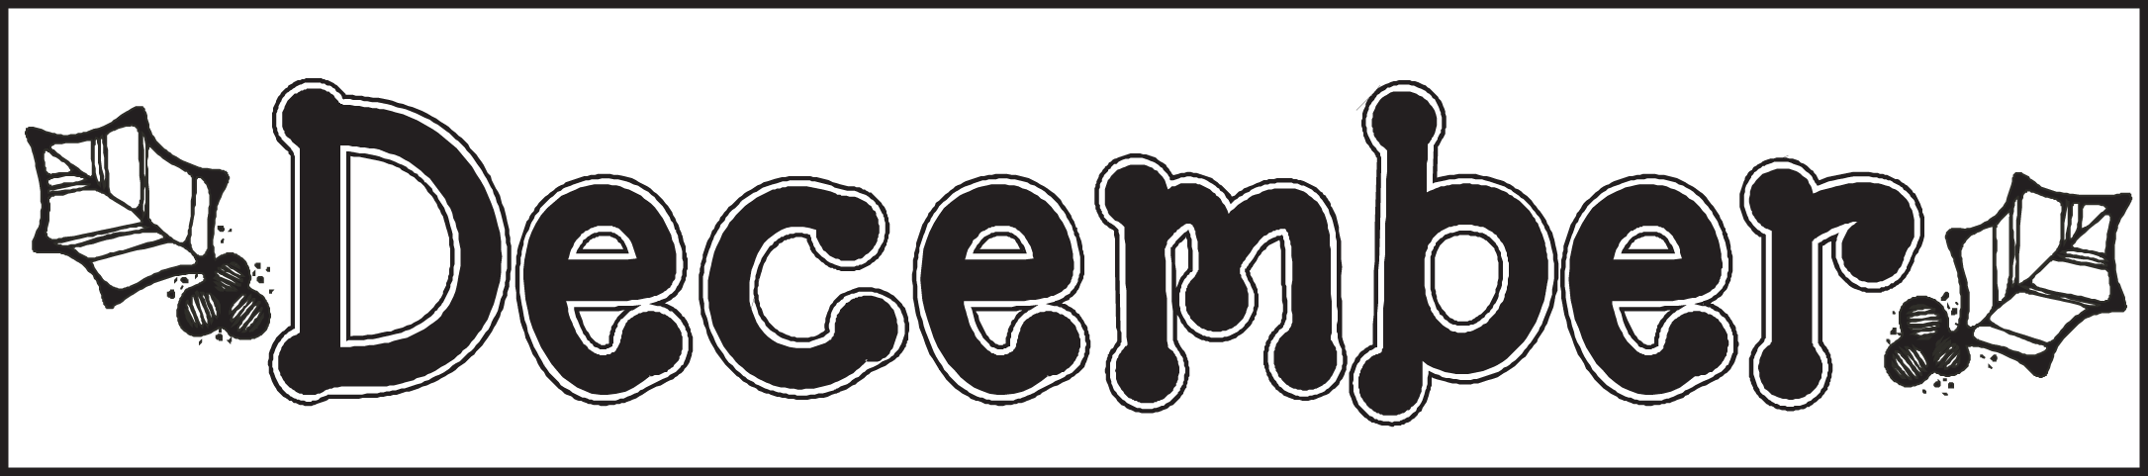
Mrs. Soderquist’s Class psoderquist@ttsd.k12.or.us
Room 109 503.431.4760
http://mrssoderquistclass.weebly.com
Our Specials Schedule

A, D Days = Lab
B, E Days = P.E.
C, F Days = Music
Mondays = Library

Dates to Remember:

12/8 Winter Holiday Night 6:30-8:30pm
12/15 Classroom party 1:50-2:25
12/18 Winter Break begins
1/2 First day back after Winter Break

Math
We are finishing up Unit 3-
- Solve addition & subtraction equations with an unknown partner or total.
- Represent and solve addition and subtraction story problems.

Homework
Thank you for helping your child establish strong study habits. Daily reading practice is so important. Make sure to check for the weekly homework page. Full weeks consist of: a reading log (expecting 10 minutes each day) and a math practice page. Check your student’s work. Help them begin identifying their own errors. Common errors include backward numbers and letters.

Extend your child’s learning by getting him/her to think more deeply. Challenge them to evaluate, justify, and explain.
- Ask them and tell them why (Not tonight because…)
- Discuss problems and encourage your child to think of solutions. If this is difficult, brainstorm ideas together.

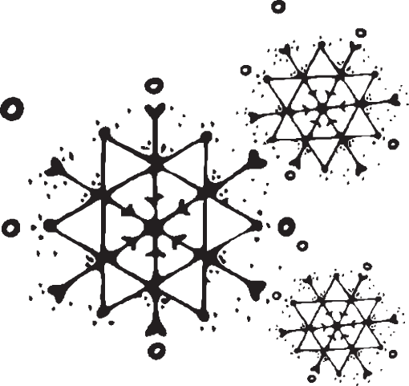

Reading
Reading to and with your child is a great way to spend quality time with them and help them improve their skills.

Reading to them exposes them to vocabulary and stories that may otherwise be too difficult. It also allows them to focus on what is happening. You might ask your child:
- WHO are the main characters?
- WHAT is the setting? (WHERE & WHEN the story takes place)
- WHAT happened in the beginning, middle, & end?
- WHAT is the problem? HOW was it solved?

Writing
This month we will wrap up our unit on opinion writing. Our next focus is expository writing. Students will continue to practice the components of a paragraph: topic sentence, detail sentences, and concluding sentence.

Students are expected to write complete sentences that start with a capital letter and end with a period, question mark, or exclamation mark. Work on identifying capitals that are not used correctly (only use them for proper nouns, titles and first letter in a sentence).

