

Mrs. Soderquist’s Class Room 109

Dates to Remember:

11/3 Fall Harvest Class Party

11/3 Fall Harvest Dance 6:30pm

11/6 OMSI Night

11/9 No School- Teacher Work Day

11/10 No School- Veteran’s Day

11/18 Garden Work PARTY 9-11am

11/23-11/24 No School-Thanksgiving Holiday

Our Specials Schedule

A & D Days = Computer

B & E Days = P.E.

C & F Days = Music



Morning Routines

Now that we have established 1st grade routines, we ask that you drop your child off in the gym, or if our class has already left, drop them off in the rotunda instead of the classroom. We want to encourage independence and confidence.

**Reading**

Your child should be reading 10 minutes each night for homework. We strongly encourage you to have him/her read out loud at least part of the time to build their oral reading fluency. The decodables are perfect for this!

How else can you help at home? Say a word and have them break it into parts, just like they would when they are trying to spell an unfamiliar word. For example:

dog d-o-g

back b-a-ck

teacher t-ea-ch-er

This will benefit readers of all abilities. It can be done in short bursts in the car or during those in between moments.

Over the years, the data at our school shows that many students who met benchmark in the primary grades later had difficulty in the upper grades maintaining their accuracy. As students progress through the grades and encounter more challenging words, we want them to continue to sound out words rather than refer to a less effective strategy. This strategy can also transfer over to their writing and help them with spelling!

**Digging deeper…**

* Ask your child if a book is nonfiction or fiction and how they know.
* Model speaking in complete sentences when you talk with your child and encourage him/her to do the same.
* Your child may know the answer to math questions but can they explain why or how they got that answer?



**Writing**

We are continuing to write opinion pieces. Students are to introduce the topic by stating an opinion, supply a reason for the opinion, and provide some sense of closure.



[psoderquist@ttsd.k12.or.us](mailto:psoderquist@ttsd.k12.or.us)

503.431.4760

E**MERGENCY DRILLS:** We practice safety drills every month in all of our schools within the Tigard-Tualatin School District. Safety is our most important job every day we are with your children. There are a few important things to know about our emergency drills. Once a month we practice fire drills. We also practice lockout and lockdown drills. These opportunities help us ensure that every child and adult in our school is accounted for and safe in case of emergency. Here are a few basics to help you understand three important practice drills that we run here at school:

**Fire Drills:** Once a month. All staff and students evacuate the school to designated areas around the outside of our school property.

**Lockout & Lockdown Drills:** Two times a year. One fall drill and one winter drill.

Lockout Drills include:

* Lockout announcement to entire school
* Any students and staff outside the school are brought inside
* Attendance is reviewed
* All outside doors are locked, no one is allowed in during lockout drills
* All blinds and window coverings are closed
* School activity inside the school runs on regular schedule

Lockdown Drills include:

* Lockdown announcement to entire school
* All staff and students are cleared from common and hallway spaces
* All outside and inside doors locked
* All outside and inside windows covered and closed
* All staff direct students and visitors to locations that are out of sight
* Attendance is reviewed and silence is expected
* All clear signal is announced when completed

Please contact your child’s teacher or our office for any questions for how we practice safety at school. Dates for practice drills are not posted as they are all subject to change.

**Math**

**Areas of focus for Unit 3**  
 - Solve addition & subtraction

equations with an unknown

partner or total.   
 - Represent and solve addition and

subtraction story problems   
 - Addition & subtraction fluency

**Vocabulary**  
 - Unknown addend   
 - Fact Family/math mountain

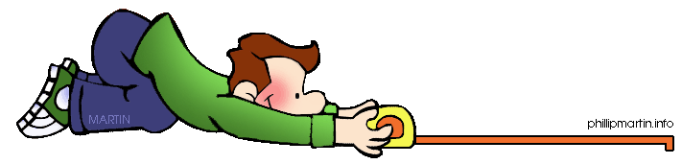

**Areas of focus for Measurement Unit**  
 - Measure object using different units

**Vocabulary**

* units
* long/longer/longest
* short/shorter/shortest
* order
* measure

